1.

A

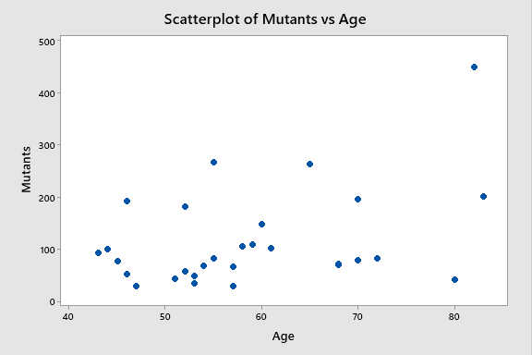

B

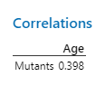

C

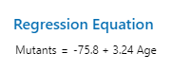

2.

A

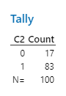

B

C

3.

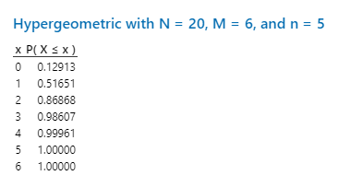

A

Probability of

B

Probability of:

= 0.4831

C

